What do I know?
- Joint Space Control
- PD control with gravity compensation
- Inverse dynamics control
- Robust control
- Adaptive control
- Operational Space control
- PD control with gravity compensation
- Inverse dynamics control
- Force Control
- Impedance control
- Parallel force/position control

Robot dynamics
Consider the torque $τ$ is generated by motor dynamics, the robot dynamics can be addressed based on the command signal $u$ as:
$$\begin{aligned}B\left(q\right)\ddot{q}+C\left(q,\dot{q}\right)+F\dot{q}+g\left(q\right)=u\#\left( SEQ 方程式 \backslash * ARABIC 1\right)\end{aligned}$$
$$F=F_{v}+K_{r}K_{t}R_{a}^{-1}K_{v}K_{r}, u=K_{r}K_{t}R_{a}^{-1}G_{v}v_{c}$$
Where $B\left(q\right)$ is inertia matrix, $C\left(q,\dot{q}\right)$ is Coriolis-centripetal matrix, $g\left(q\right)$ is gravitational, $F_{v}$ is viscous friction, $K_{r}$ is gear ratio matrix, $K_{t}$ is motor torque constant matrix, $R_{a}$ is motor armature resistance matrix, $v_{c}$ is motor armature voltage, $K_{v}$ is motor voltage constant matrix, $G_{v}$ is amplifier gain matrix.

In this section, we’re going to use Matlab to simulate some of the controllers on IRISS v2 robot used for robotic eye surgery.
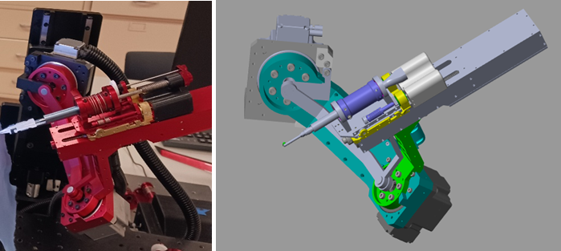
Figure 1: IRISS v2 robot.

Joint Space Control

PD control with gravity compensation
$$\begin{aligned}u=g\left(q\right)+K_{p}\tilde{q}-K_{d}\dot{q}\#\left( SEQ 方程式 \backslash * ARABIC 2\right)\end{aligned}$$
$$\tilde{q}=q_{d}-q$$
Where $q_{d}$ is desired joint position. Since there is only joint position command in this controller, it’s usually used for pose maintenance.
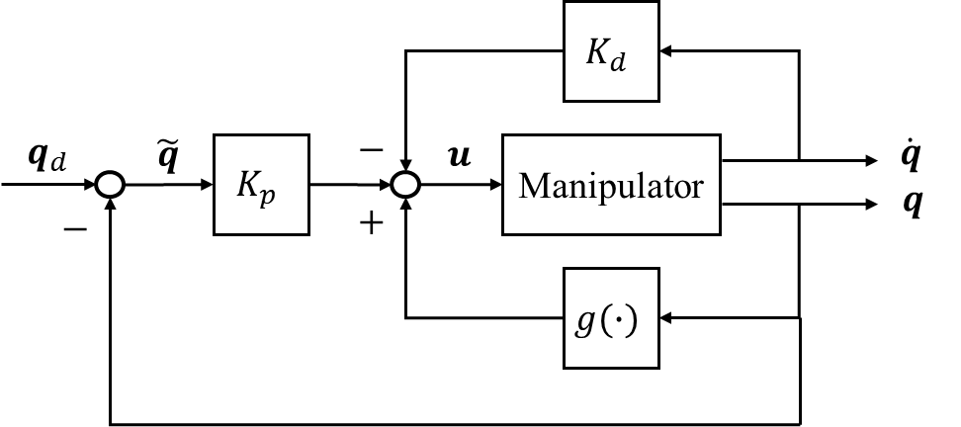
Figure 2: Block diagram of PD control with gravity compensation.
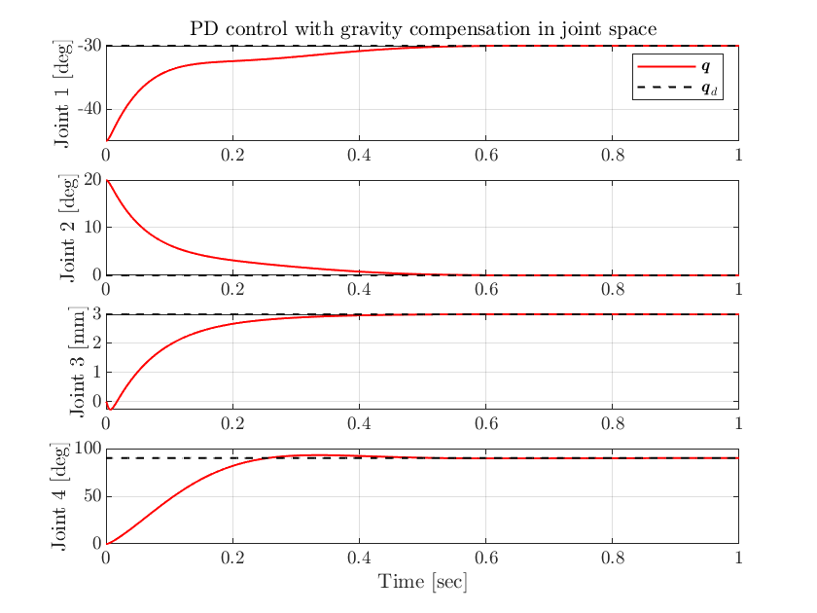
Figure 3: Joint position tracking Matlab simulation.

Inverse dynamics control (Computed torque control)
Based on the robot dynamics model and the double integrator relationship, inverse dynamics control can achieve trajectory following with desired joint position, velocity and acceleration command.
$$\begin{aligned}u=B\left(q\right)y+n\left(q,\dot{q}\right)\#\left( SEQ 方程式 \backslash * ARABIC 3\right)\end{aligned}$$
$$n\left(q,\dot{q}\right)=C\left(q,\dot{q}\right)+F\dot{q}+g\left(q\right)$$
$$\begin{aligned}\ddot{q}=y={\ddot{q}}_{d}+K_{d}\dot{\tilde{q}}+K_{p}\tilde{q}\#\left( SEQ 方程式 \backslash * ARABIC 4\right)\end{aligned}$$
$$\dot{\tilde{q}}={\dot{q}}_{d}-\dot{q}, \tilde{q}=q_{d}-q$$
Where $q_{d}$ is desired joint position, ${\dot{q}}_{d}$ is desired joint velocity, and ${\ddot{q}}_{d}$ is desired joint acceleration.
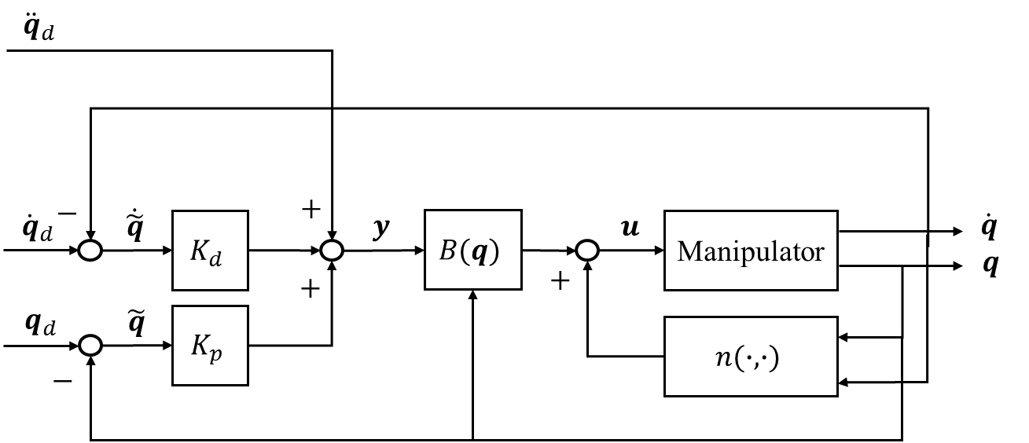
Figure 4: Block diagram of inverse dynamics control.
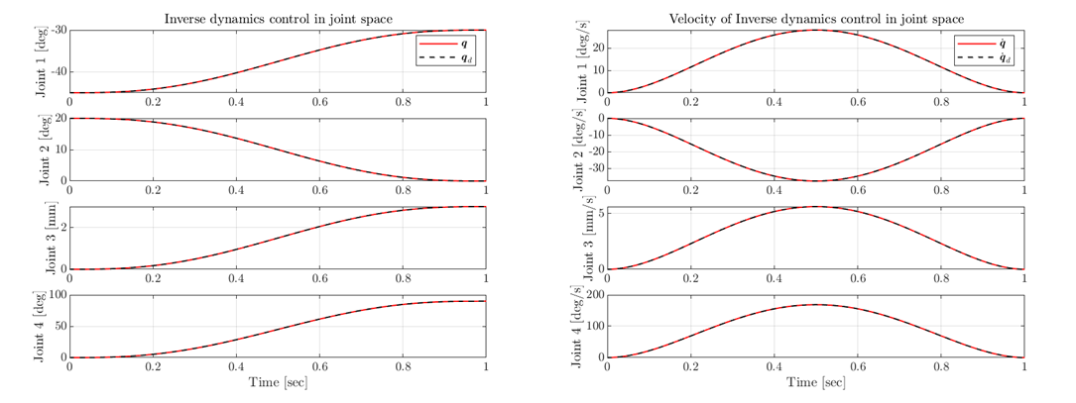
Figure 5: Joint position and velocity tracking Matlab simulation.
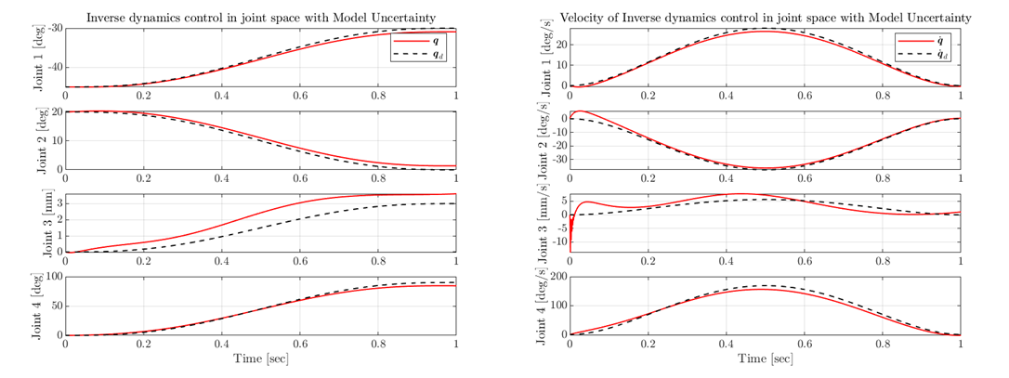
Figure 6: Joint position and velocity tracking Matlab simulation with model uncertainty.
Although inverse dynamics control works perfectly while the estimated model matches the actual robot dynamics, the tracking performance decreases when they’re not the same.

Robust control
Robust control ensures the asymptotical stability of the controlled system while the model uncertainty exists.
$$\begin{aligned}u=\hat{B}\left(q\right)y+\hat{n}\left(q,\dot{q}\right)\#\left( SEQ 方程式 \backslash * ARABIC 5\right)\end{aligned}$$
$$\begin{aligned}y={\ddot{q}}_{d}+K_{d}\dot{\tilde{q}}+K_{p}\tilde{q}+ρ\frac{z}{\left\|z\right\|}\#\left( SEQ 方程式 \backslash * ARABIC 6\right)\end{aligned}$$
$$z=D^{T}Qξ$$
$$D=\left[\begin{matrix}0 \\ I\end{matrix}\right], ξ=\left[\begin{matrix}\tilde{q} \\ \dot{\tilde{q}}\end{matrix}\right]$$
Where the estimated matrices, $\hat{B}\left(q\right)$ and $\hat{n}\left(q,\dot{q}\right)$, are different from the actual ones, $B\left(q\right)$ and $n\left(q,\dot{q}\right)$. And, $Q$ is a positive-definite matrix, both $ρ$ and $Q$ are tuning parameters depending on the size of model uncertainty.
Mean Error | Position |  | Velocity
Controller | Inverse Dynamics | Robust | Inverse Dynamics | Robust
Joint 1 [$°$] | 0.4596 | 0.4542 | 0.9309 | 0.9259
Joint 2 [$°$] | 0.9496 | 0.9316 | 1.3653 | 1.3574
Joint 3 [$mm$] | 0.6356 | 0.6214 | 1.5568 | 1.5308
Joint 4 [$°$] | 2.2136 | 2.0537 | 8.5979 | 7.9479
Table 1: Mean error comparison of Matlab simulation between inverse dynamics and robust control.
According to Matlab simulation result, robust control slightly improves the tracking performance.

Adaptive control
To draw the issue of model uncertainty, the other method is adaptive control, which learns model parameters iteratively online based on the robot dynamic response to the input motor command.
The dynamic model is reformulated into:
$$\begin{aligned}Y\left(q,\dot{q},\ddot{q}\right)π=u\#\left( SEQ 方程式 \backslash * ARABIC 7\right)\end{aligned}$$
Where $Y\left(q,\dot{q},\ddot{q}\right)$ is regressor matrix, and $π$ is a vector of constant dynamic model parameters such as link length and offset.
The control law is:
$$\begin{aligned}u=Y\left(q,\dot{q},{\dot{q}}_{r},{\ddot{q}}_{r}\right)\hat{π}+K_{d}σ\#\left( SEQ 方程式 \backslash * ARABIC 8\right)\end{aligned}$$
$${\dot{q}}_{r}={\dot{q}}_{d}+Λ\tilde{q}$$
$${\ddot{q}}_{r}={\ddot{q}}_{d}+Λ\dot{\tilde{q}}$$
$$σ=\dot{\tilde{q}}+Λ\tilde{q}$$
Where $\hat{π}$ is estimated model parameter vector, and $Λ$ is a positive-definite (usually diagonal) matrix.
The adaptive law is:
$$\begin{aligned}\dot{\hat{π}}=K_{π}^{-1}Y^{T}\left(q,\dot{q},{\dot{q}}_{r},{\ddot{q}}_{r}\right)σ\#\left( SEQ 方程式 \backslash * ARABIC 9\right)\end{aligned}$$
Where $K_{π}$ is a positive-definite matrix that determines the rate of convergence of dynamic model parameters to their asymptotic values.

Operational Space Control
Analytical Jacobian $J_{A}(q)$ is a transformed version of geometric Jacobian $J(q)$ which is obtained by differentiating forward kinematic equations. Analytical Jacobian is necessary for operational space control, which requires to represent end-effector orientation and changes in end-effector orientation. Analytical Jacobian maps joint angle velocity into angular velocity expressed in rates of change in Euler angle. Geometric Jacobian maps joint angle velocity into angular velocity vector $ω$ which is more physical meaningful.
$$\begin{aligned}\dot{x}=\left[\begin{matrix}\dot{p} \\ \dot{ϕ}\end{matrix}\right]=J_{A}\left(q\right)\dot{q}\#\left( SEQ 方程式 \backslash * ARABIC 10\right)\end{aligned}$$
$$\begin{aligned}v=\left[\begin{matrix}\dot{p} \\ ω\end{matrix}\right]=J\left(q\right)\dot{q}=\left[\begin{matrix}I & 0 \\ 0 & T\left(ϕ\right)\end{matrix}\right]\left[\begin{matrix}\dot{p} \\ \dot{ϕ}\end{matrix}\right]=T_{A}\left(ϕ\right)J_{A}\left(q\right)\dot{q}\#\left( SEQ 方程式 \backslash * ARABIC 11\right)\end{aligned}$$
Where $ϕ$ is 3D orientation using minimal representation (ie. Euler angle), and $T(ϕ)$ is a rotational matrix that uses the parameters from minimal representation of 3D orientation.

PD control with gravity compensation
$$\begin{aligned}u=g\left(q\right)+J_{A}^{T}\left(q\right)K_{p}\tilde{x}-J_{A}^{T}\left(q\right)K_{d}J_{A}\left(q\right)\dot{q}\#\left( SEQ 方程式 \backslash * ARABIC 12\right)\end{aligned}$$
$$\tilde{x}=x_{d}-x$$
Where $x_{d}$ is desired position and orientation in operational space.
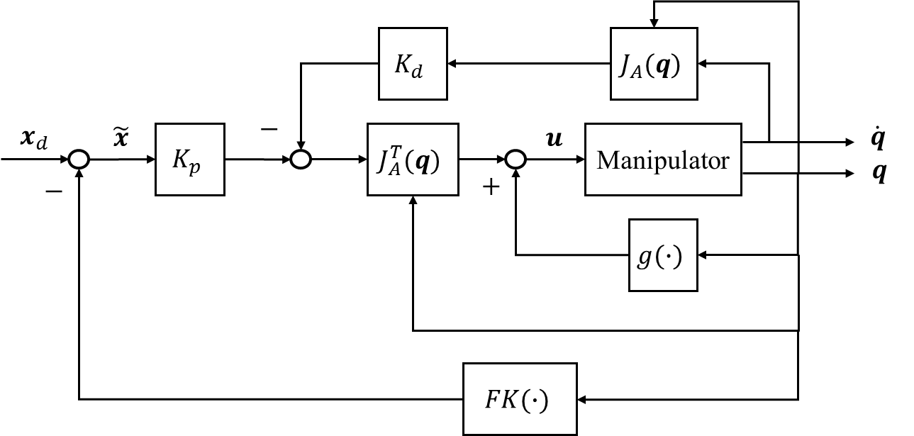
Figure 7: Block diagram of PD control with gravity compensation in operational space.
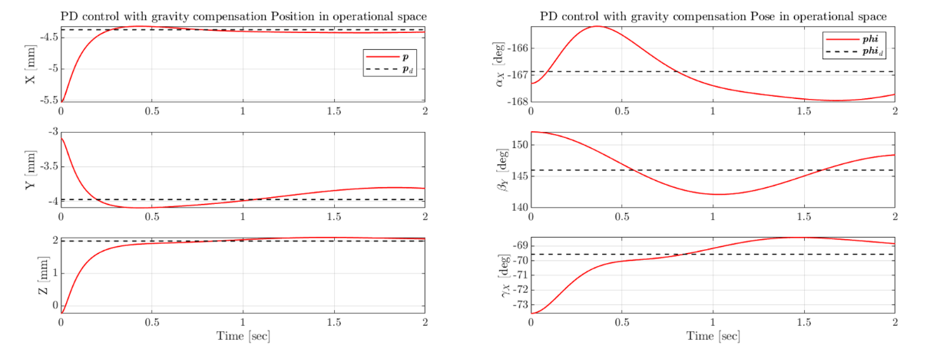
Figure 8: Position and pose represented in XYX Euler angle tracking Matlab simulation.

Inverse dynamics control
$$\begin{aligned}u=B\left(q\right)y+n\left(q,\dot{q}\right)\#\left( SEQ 方程式 \backslash * ARABIC 13\right)\end{aligned}$$
$$\begin{aligned}\ddot{q}=y=J_{A}^{-1}\left(q\right)\left({\ddot{x}}_{d}+K_{d}\dot{\tilde{x}}+K_{p}\tilde{x}-{\dot{J}}_{A}\left(q,\dot{q}\right)\dot{q}\right)\#\left( SEQ 方程式 \backslash * ARABIC 14\right)\end{aligned}$$
$$\dot{\tilde{x}}={\dot{x}}_{d}-\dot{x}, \tilde{x}=x_{d}-x$$
Where $x_{d}$ is desired position and orientation, and ${\dot{x}}_{d}$/${\ddot{x}}_{d}$ is desired velocity/acceleration and angular velocity/acceleration in operational space.
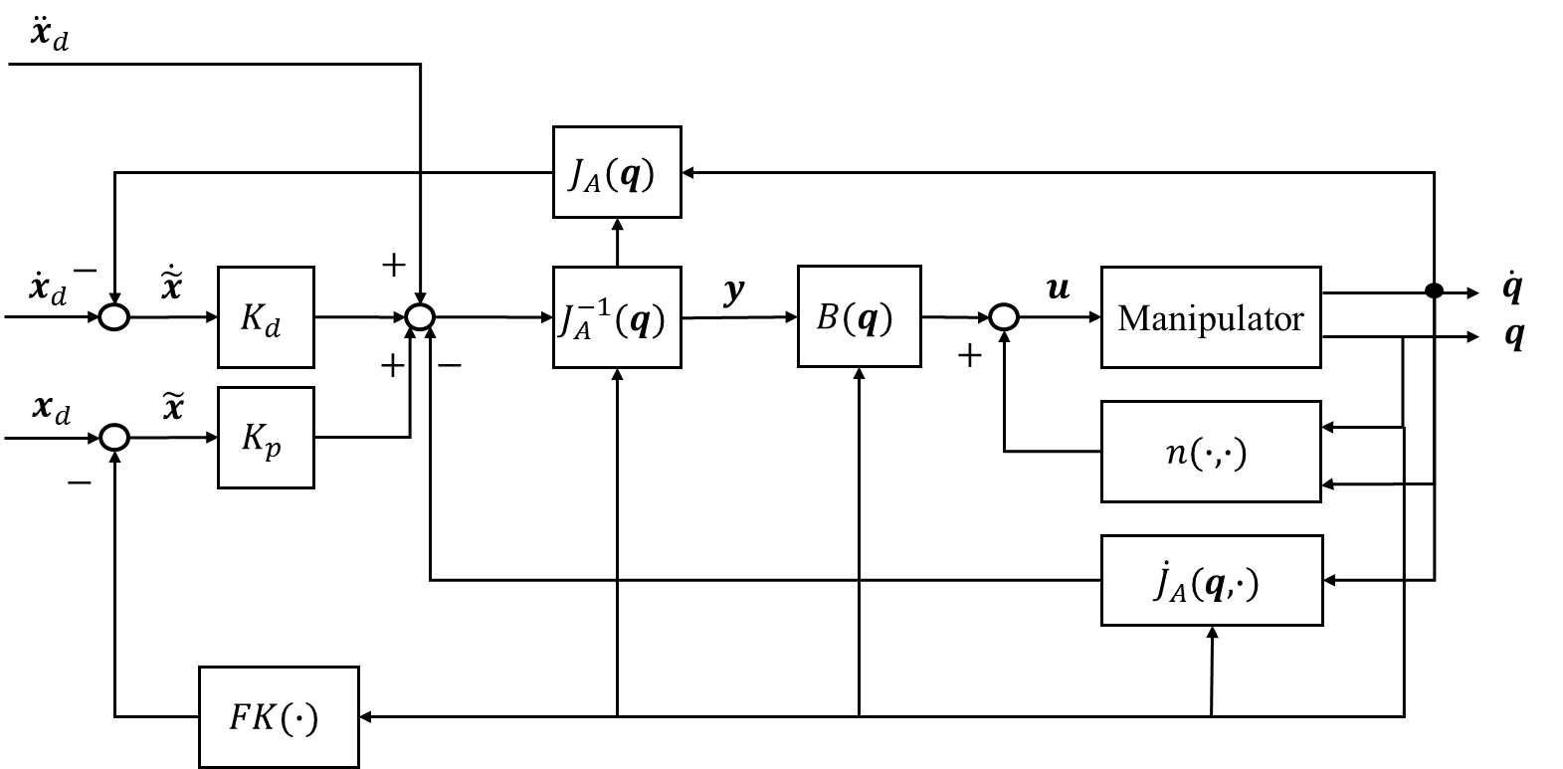
Figure 9: Block diagram of inverse dynamics control in operational space.
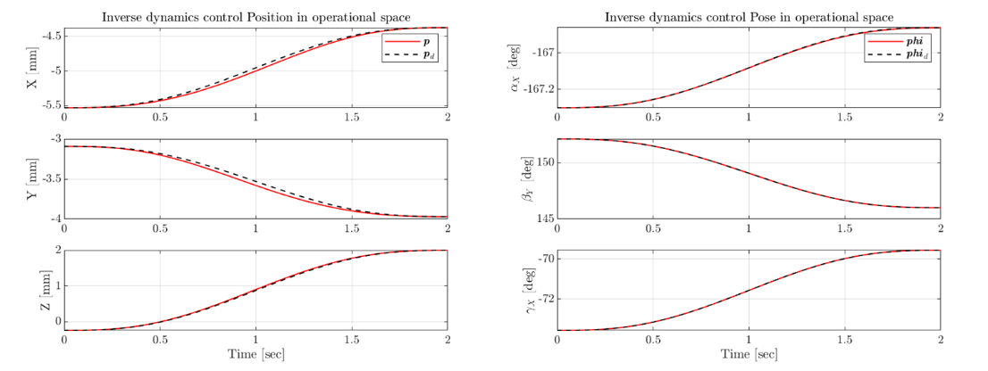
Figure 10: Position and pose tracking Matlab simulation.
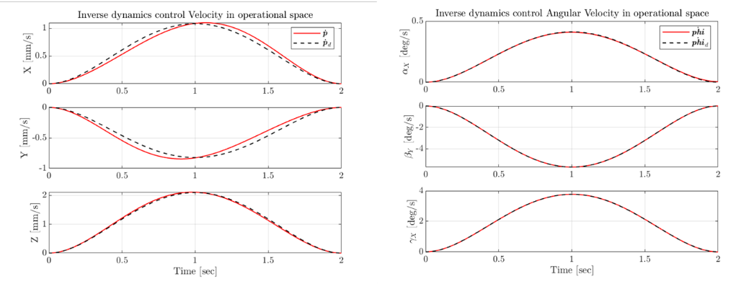
Figure 11: Velocity and angular velocity tracking Matlab simulation.

Force Control
Now, we start to consider the force exerted from the robot to the environment $h$, and the robot dynamics can be written as:
$$\begin{aligned}B\left(q\right)\ddot{q}+C\left(q,\dot{q}\right)+F\dot{q}+g\left(q\right)=u-J^{T}\left(q\right)h\#\left( SEQ 方程式 \backslash * ARABIC 15\right)\end{aligned}$$
For the previous controllers, no matter how much the force exerted on the robot, the robot will keep moving to the exact desired location. In some circumstance, this is quite dangerous, which can hurt people or damage the environment. Therefore, we want the robot can interact with the environment, and response to the external forces.

Impedance control
The error vector $\tilde{x}=x_{d}-x$ in previous section will be expressed in the desired orientation frame:
$$\begin{aligned}\tilde{x}=\left[\begin{matrix}R_{d}^{T}\left(p_{d}-p\right) \\ ϕ_{d}-ϕ\end{matrix}\right]\#\left( SEQ 方程式 \backslash * ARABIC 16\right)\end{aligned}$$
And, the PD controller becomes:
$$\begin{aligned}u=g\left(q\right)+J_{A_{d}}^{T}\left(q,\tilde{x}\right)\left(K_{p}\tilde{x}-K_{d}J_{A_{d}}\left(q,\tilde{x}\right)\dot{q}\right)\#\left( SEQ 方程式 \backslash * ARABIC 17\right)\end{aligned}$$
$$\begin{aligned}J_{A_{d}}\left(q,\tilde{x}\right)=\left[\begin{matrix}I & 0 \\ 0 & T^{-1}\left(ϕ-ϕ_{d}\right)\end{matrix}\right]\left[\begin{matrix}R_{d}^{T} & 0 \\ 0 & R_{d}^{T}\end{matrix}\right]J\left(q\right)\#\left( SEQ 方程式 \backslash * ARABIC 18\right)\end{aligned}$$
In addition, inverse dynamics control becomes:
$$\begin{aligned}u=B\left(q\right)y+n\left(q,\dot{q}\right)+J^{T}\left(q\right)h\#\left( SEQ 方程式 \backslash * ARABIC 19\right)\end{aligned}$$
$$\begin{aligned}y=J_{A_{d}}^{-1}\left(q,\tilde{x}\right)M_{d}^{-1}\left(K_{d}\dot{\tilde{x}}+K_{p}\tilde{x}-M_{d}{\dot{J}}_{A_{d}}\left(q,\tilde{x},\dot{q},\dot{\tilde{x}}\right)\dot{q}+M_{d}\dot{b}-h^{d}\right)\#\left( SEQ 方程式 \backslash * ARABIC 20\right)\end{aligned}$$
Where $M_{d}$, $K_{d}$ and $K_{p}$ are tunable matrices, and $h^{d}$ is the force represented on the desired pose frame.
After plugging $(19)$ into $(15)$, the dynamic can be simplified to linear impedance relationship independent of the configuration of the manipulator:
$$M_{d}\ddot{\tilde{x}}+K_{d}\dot{\tilde{x}}+K_{p}\tilde{x}=h^{d}$$
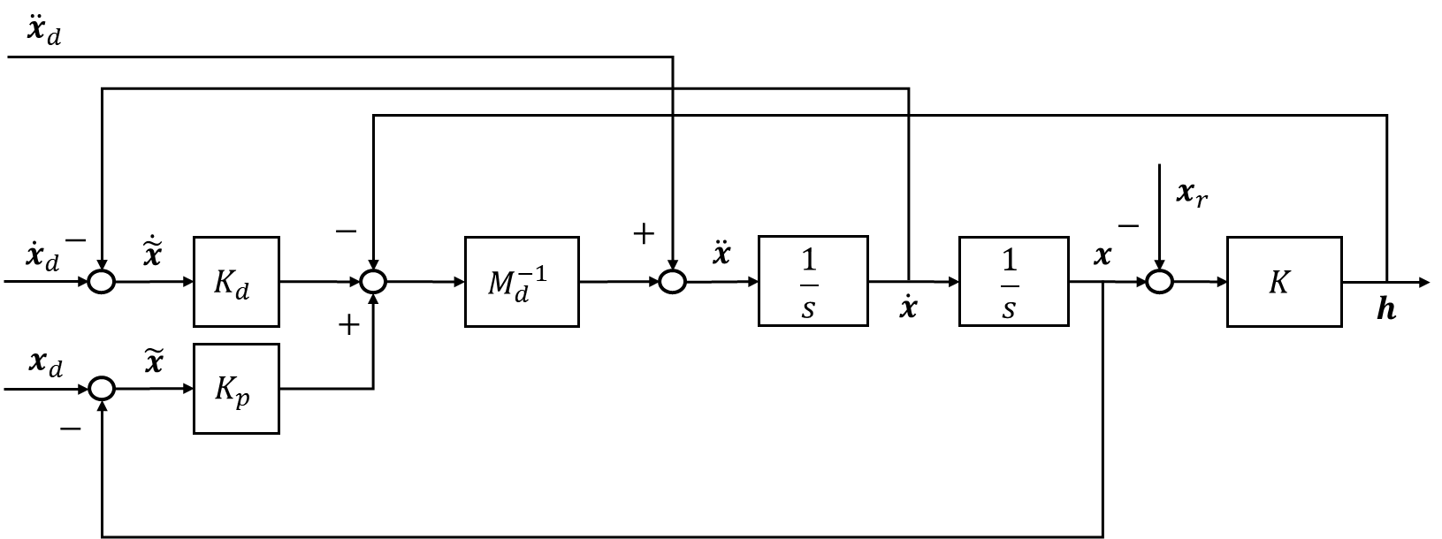
Figure 12: Block diagram of impedance control. $x_{r}$ can be a reference point, line or plane. $K$ is the spring constant of the environment.
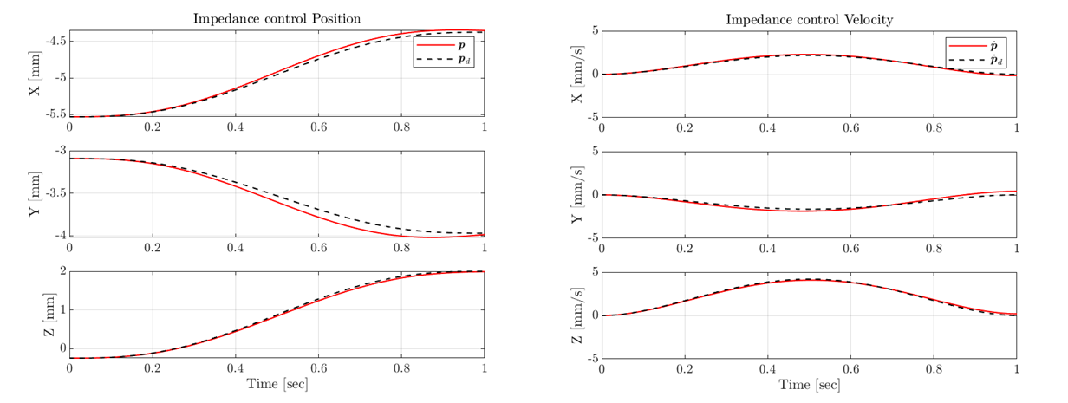
Figure 13: Position and velocity tracking Matlab simulation.
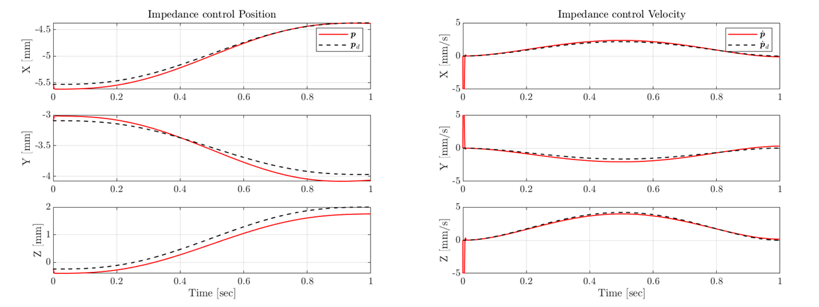
Figure 14: Position and velocity tracking Matlab simulation with exerting 100 N force along z-axis.
When the end-effector exerts a constant force along positive z-axis, which means there might be an obstacle near the desired position, its position has never reached the desired value. In other words, the end-effector gently touched the obstacle instead of colliding into that violently to reach the target.

Parallel force/position control
$$\begin{aligned}u=B\left(q\right)y+n\left(q,\dot{q}\right)\#\left( SEQ 方程式 \backslash * ARABIC 21\right)\end{aligned}$$
$$\begin{aligned}y=J^{-1}\left(q\right)M_{d}^{-1}\left(K_{d}\dot{x}+K_{p}\left(\tilde{x}+x_{F}\right)-M_{d}{\dot{J}}_{A}\left(q,\tilde{x},\dot{q},\dot{\tilde{x}}\right)\dot{q}\right)\#\left( SEQ 方程式 \backslash * ARABIC 22\right)\end{aligned}$$
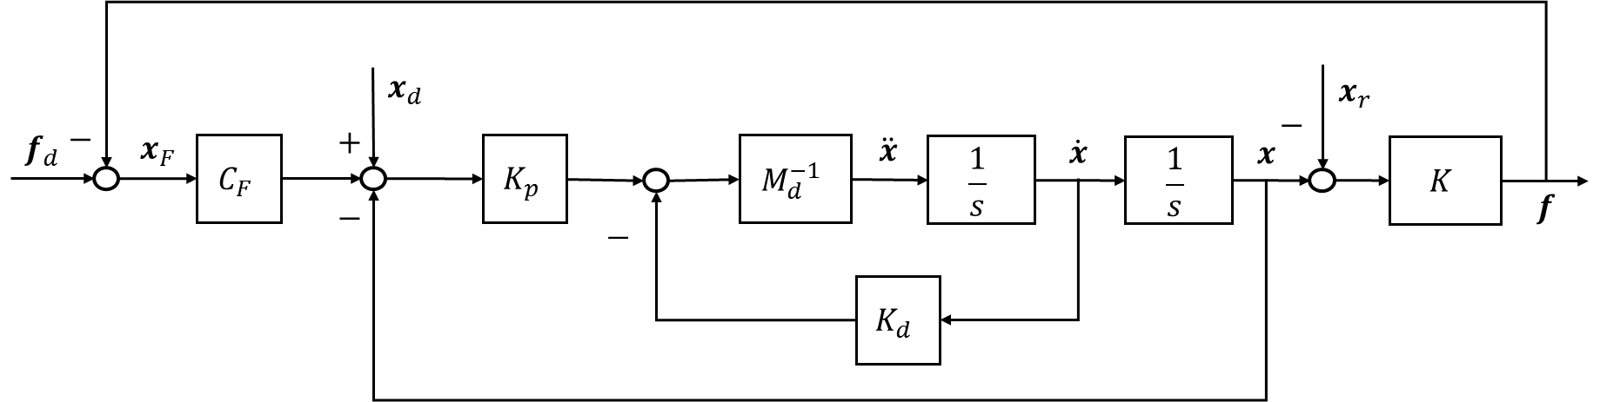
Figure 15: Block diagram of parallel force/position control. $f_{d}$ is the desired force, and $C_{F}$ is a PI controller.
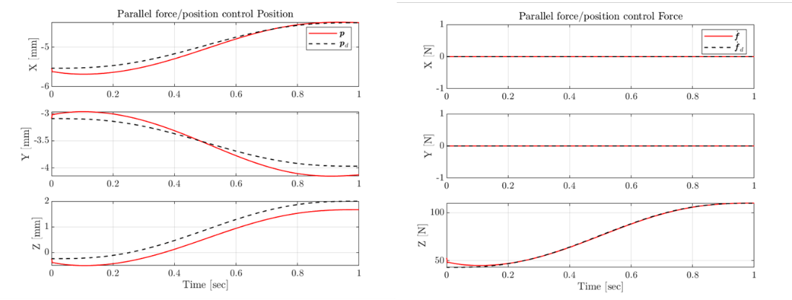
Figure 16: Position and force tracking Matlab simulation.

